**Stage 5 – Night of the living dead🧟🧟‍♂️🧟‍♀️**

**RULES:** USPSA Competition Rules, Latest Edition **COURSE DESIGNER:** John Royer

|  |  |
| --- | --- |
| **START POSITION: See written stage briefing.** | |
| **STAGE PROCEDURE**  See written stage briefing. | **SCORING**  **SCORING:** Comstock 29 rounds.  **TARGETS:** There are 14 cardboard targets and 1 steel target.  **SCORED HITS:** 2 Best hits per carboard will be scored. Steel must fall to score.  **START-STOP:**  Audible - Last shot  **PENALTIES:** Per USPSA Competition Rules |

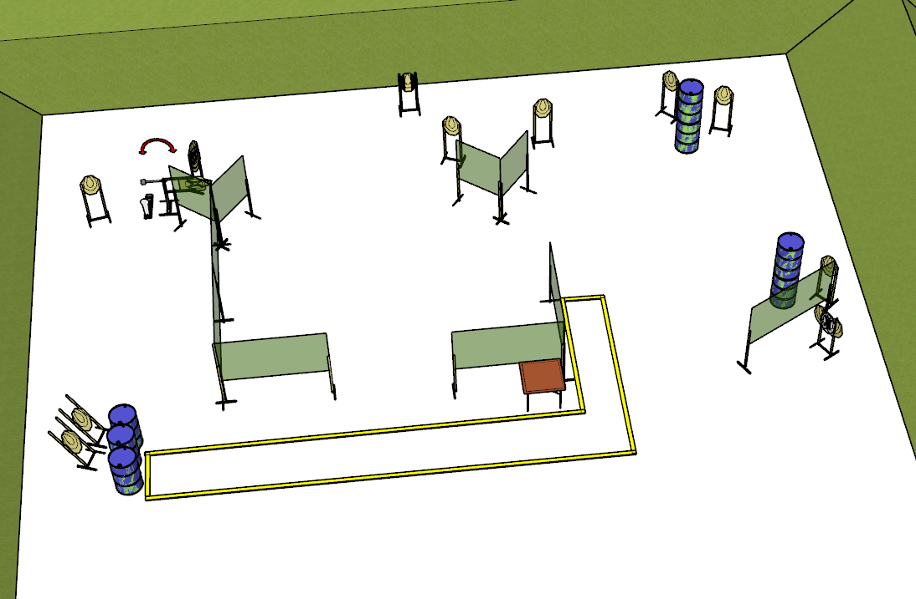

**Written Stage Briefing:**

**Stage 5 – Night of the living dead 🧟🧟‍♂️🧟‍♀️ –** is a **29-round**, **145 point**, Comstock Long Course. There are 14 cardboard targets and 1 steel target. The best 2 hits per cardboard target will be scored. The steel must fall to score. The swinger is visible at rest.

**Start position**

Both feet directly behind the start table, wrists above shoulders.

Firearm is unloaded and placed on the start table, with muzzle pointed generally downrange.

First magazine / reloading device to be used must be placed on the start table.

On the audible start signal, engage targets from within the shooting area.

**Setup Notes:**

Try to find / use the 45 degree angle target stands for the back, left targets.

9 Single Wall Stands

2 Triple Wall Stands

4 Double Wall Stand

6 Solid Walls

4 Solid Half Walls

11 Target stands (9 standard, 2 45 degree) / 22 target sticks

8+ barrels

1 Steel activator plate

1 Swinger

1 Start table